**Done by 21k-3881**

**Lab Tasks=03**

**Task 01:**

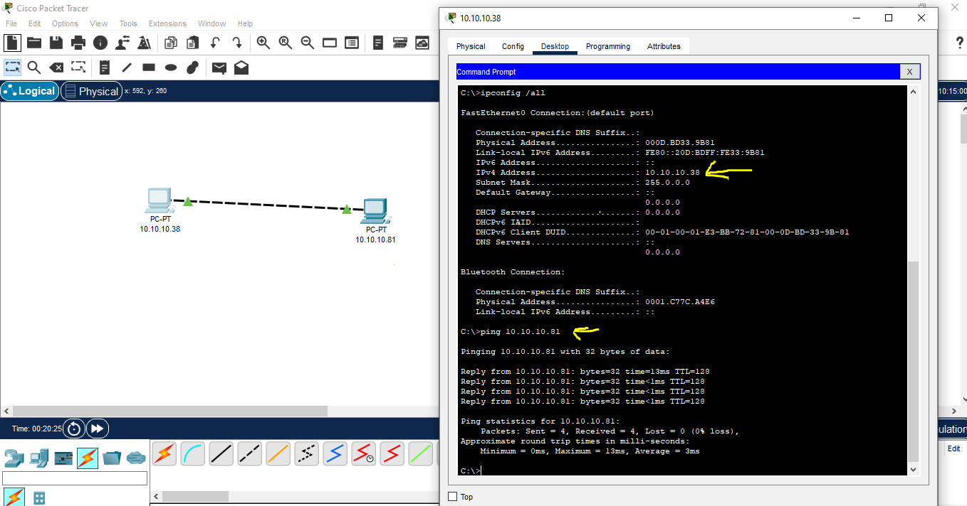

**Task 02:**

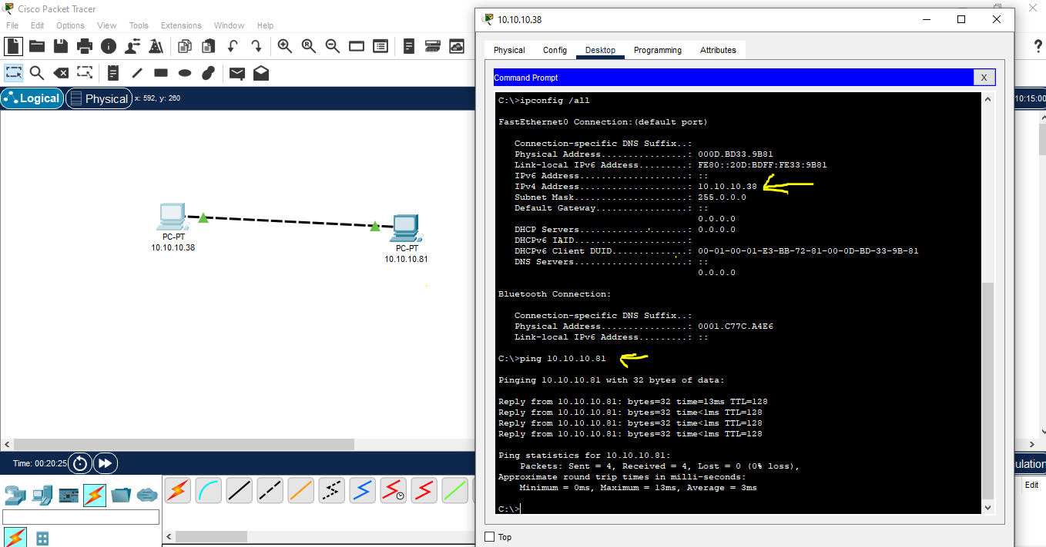

**Description:** We choose cross over cable here, because we want to connect two similar directly without using any switch or router. The primary reason for using a crossover cable in this scenario is due to the way Ethernet cables are wired.

**Task 03:**

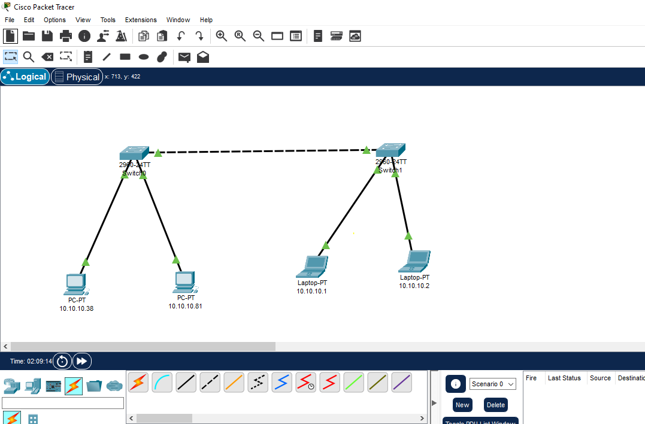

**Coneectivity:**

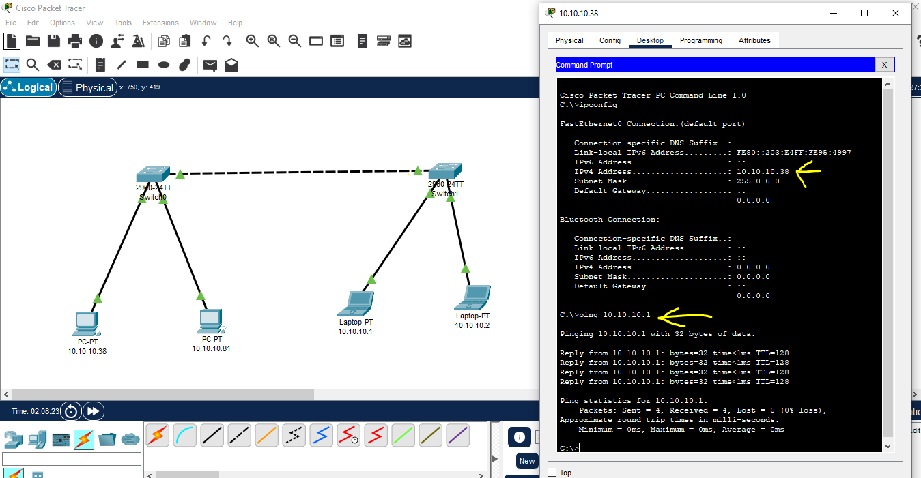

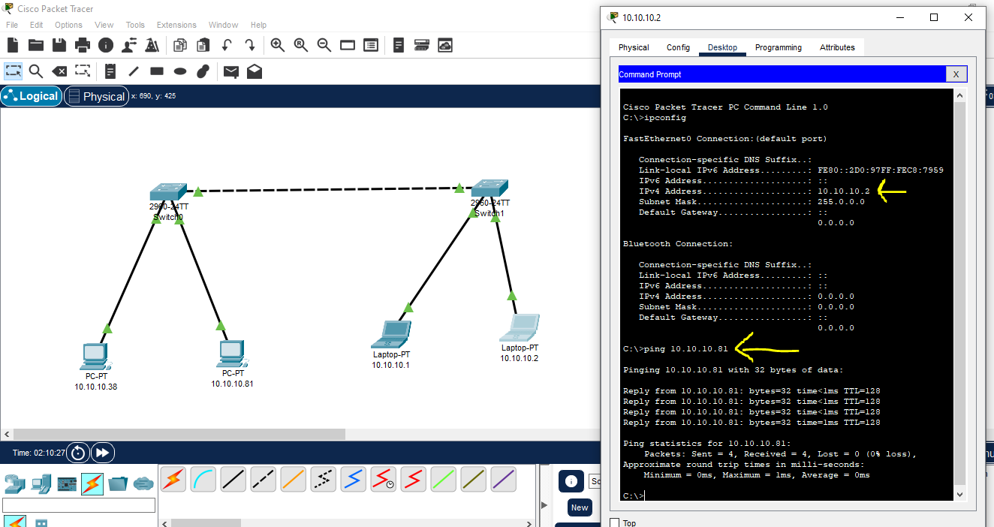

**Testing 01:** 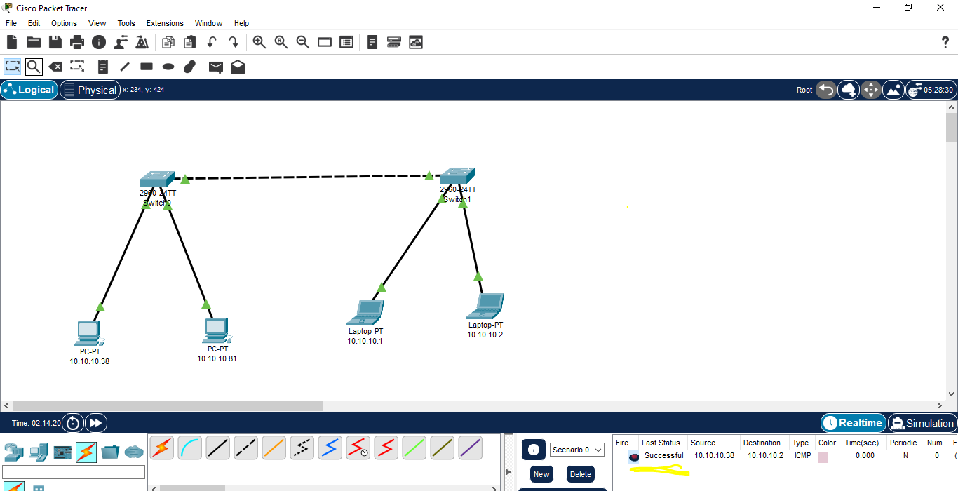

**Testing 02:**

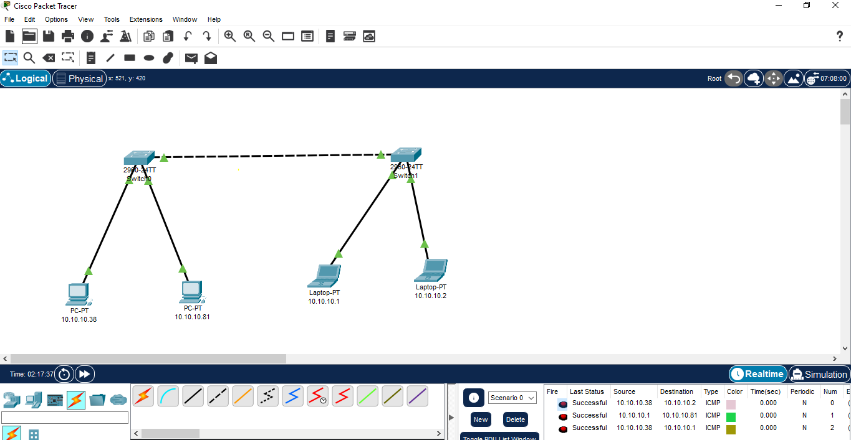

**Functionality of devices :**

In the above scenario we have used 2 switches along with 2 pcs and 2 laptops both the switches are connected to each other and each pc or laptop is connected to each other through switches. The functionality of switch is that if we transfer a massage from one pc to another , it will not transfer that message to rest of the pcs. The functionality pf of pc is that , it can sends message to rest of the computer or receives message from all the pcs.

**Task 04:**

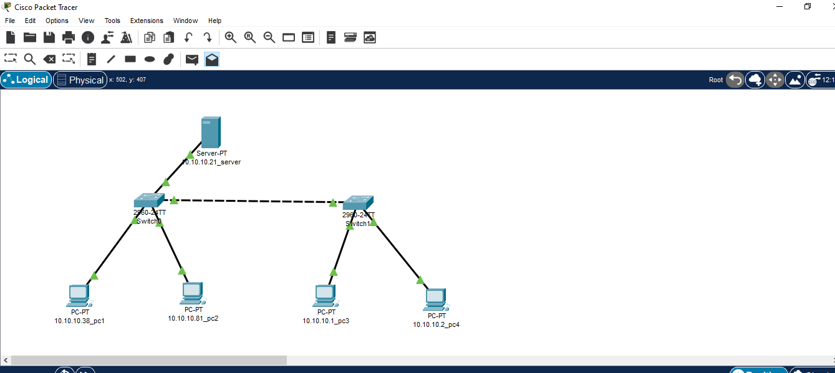

**Testing:**

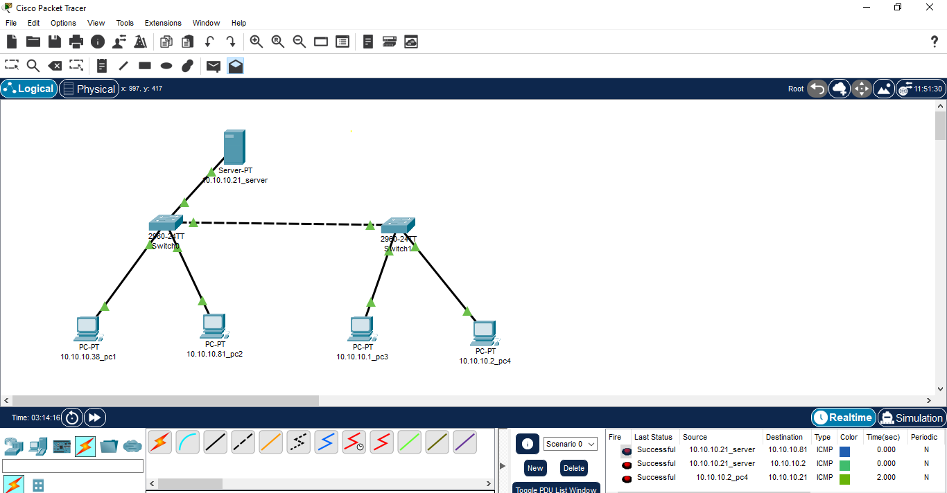

**Connectivity:**

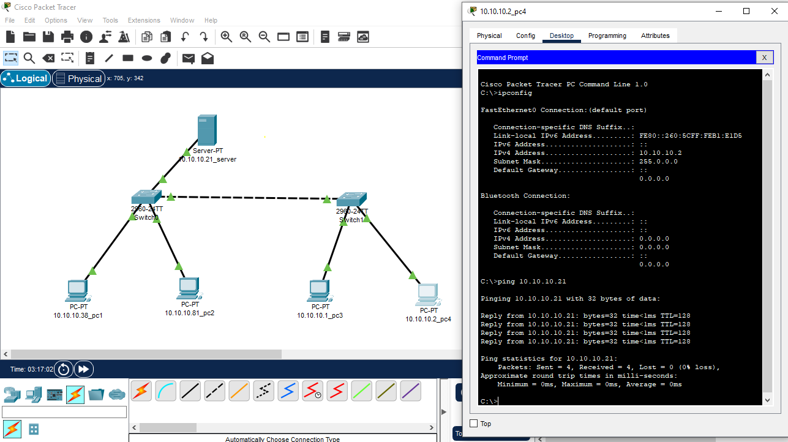

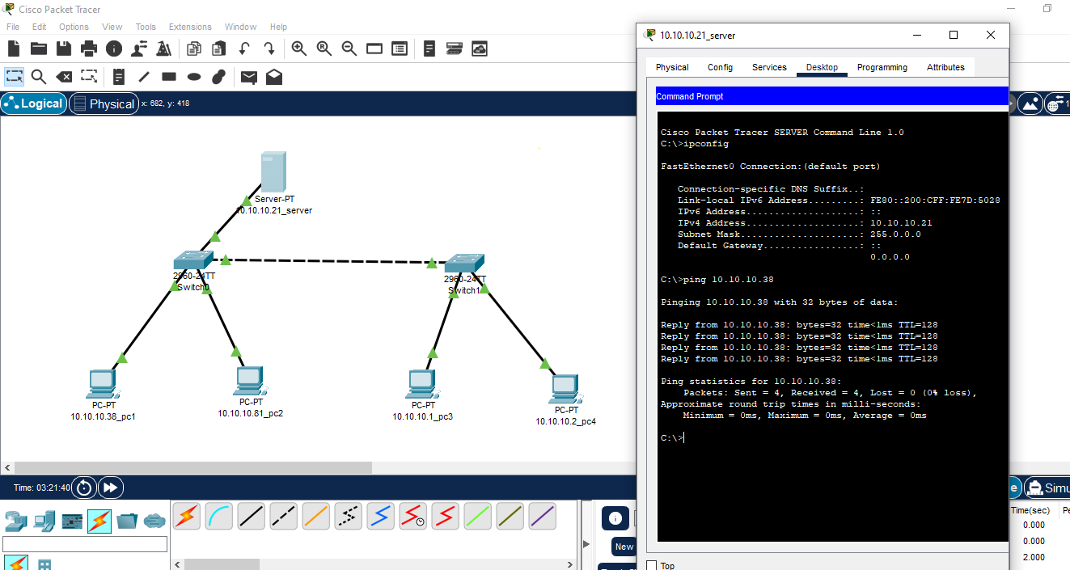

**Description:** The Server is connected to all pcs through switches. Server can send or receive message to multiple pcs or from multiple pcs. Switches can transfer message from 1 pc to specific targeted pc rather all pcs. All pcs can send or receive message to each other or to server.

**Task 05:**

Identify the difference between Switch and Hub?

**Switch:**

Switch broadcast incoming packets to the specific targeted port.

Switches maintain a MAC address table (also known as a forwarding table) to keep track of the MAC addresses of devices connected to each of its ports

**Hubs:**

Hubs broadcast incoming packets to all ports.

Hub does not maintain MAC address table. As a result, all devices connected to a hub receive the same data.